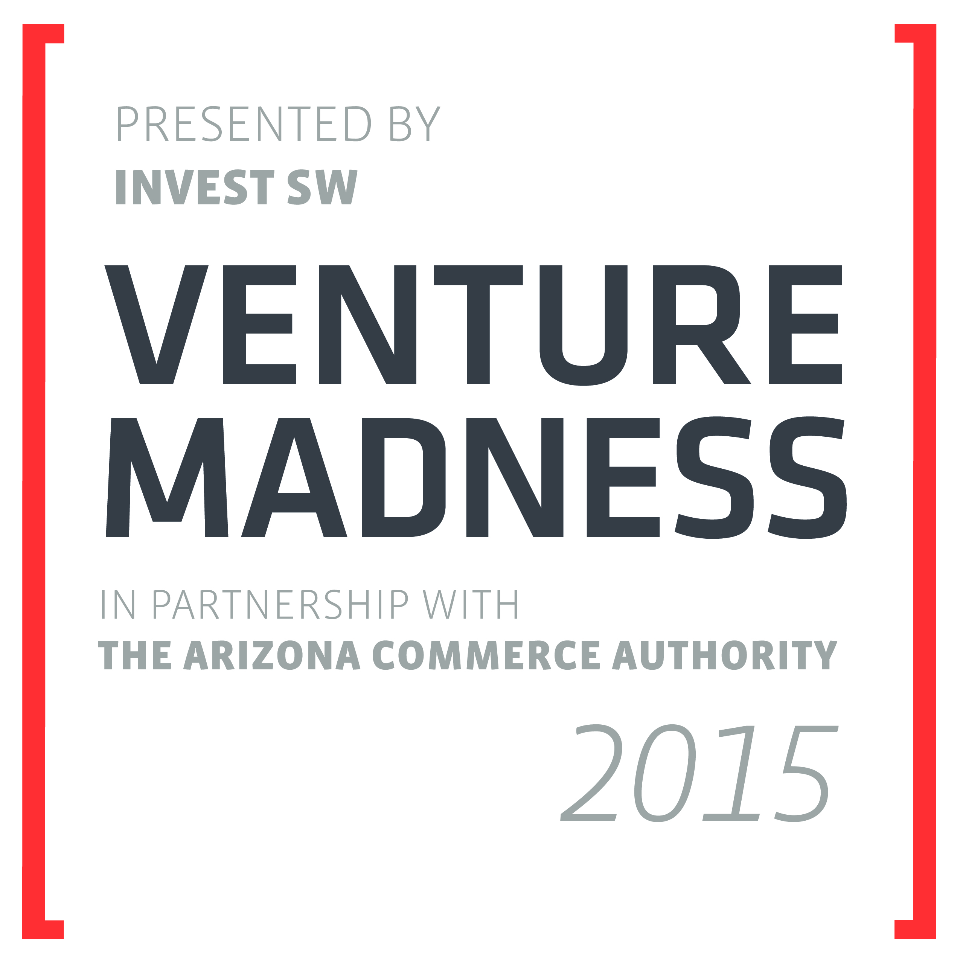
Instructions
- Due by Thursday December 18, 2014 at 3:00pm Arizona Time (AZ).
- Entries that do not comply with these instructions will not be accepted. Please read carefully!
- The information provided in this application, and in your 90-second video, must be defined as non-sensitive by your business. With the exception of this first page and the Part 6 Section, all other information is eligible to be posted for public access and viewing if selected as one of the Top 64 firms to participate in the contest. See Rules and the Terms & Conditions on the Venture Madness website.
- Complete this entire entry form using a 10-point font size. Do not change this document’s margins or alter its format.
- Your completed document must be no more than four (4) total pages: This Company Profile page is the first page. These instructions should remain intact with the fields below filled out accordingly. Parts 1 - 5 must ONLY be on the second and third pages (2 pages max). ONLY Part 6 is to be presented on the final, fourth page. The second and third pages (Parts 1-5) WILL be posted for public access if selected as one of the top 64 firms to participate. The first and fourth pages will NOT be public.
- Parts 1 - 5 below must be contained on a maximum of two pages (only on the second and third pages). For all Parts, you may change the relative sizes of the boxes’ lengths, but you must write your responses within the provided template.
- The bolded, black text in each of the boxes for parts 1 through 6 are clarifying questions and content suggestions. We understand that you may not have answers to all the questions, but more complete applications tend to get better evaluations. You may delete this bolded, black text in parts 1 through 6 as you fill in the application. Delete the red instructions.
- Save this file as a PDF (often an option in Microsoft Word’s save-as window). Please title your file “company name_VM_15.pdf”, for example, “MyCompany_VM_15.pdf”.
- To submit: Beginning Friday, November 21, 2014, visit www.VentureMadness.com and go to the “Apply” section, then click the “Submit Application” button. From there, you will fill out the form with your company profile information, upload your PDF application, and specify the link to the 90-second video to complete the submission process. This will establish your account in our online administration and evaluation system and make it possible for you to see your feedback and scores after each round.
Company Profile
Basic Information
Company Name
Contact Name
Company Website
URL of 90-second video submission (Mandatory)

Funding History
Founders (include hard cash investments only) | $ xxx,xxx | Professional investor equity | $ xxx,xxx
Friends and Family | $ xxx,xxx | Bank or professional investor debt | $ xxx,xxx
Grant funding | $ xxx,xxx | TOTAL cash funding to date | $ xxx,xxx
Funding Needs
What dollar amount of outside equity do you anticipate needing in the next 18 months? | $ xxx,xxx

Other profile questions
Affiliated university, accelerator and/or incubator, if any:
Legal form of company? (e.g. C-corp., S-corp., LLC, Partnership):
Intellectual property protection, if any:
Part 1: “Elevator” Introduction
Brief elevator pitch for your company

Part 2: Go-to-Market Plan
Who are (will be) your customers? Describe your engagement / discussions with them to date. Have you validated their needs? Prove they are buying (or will buy) your product from you.

Describe how you win customers today. Describe your future customer acquisition strategy.

Part 3: Market and Industry Analysis
How large is your market? What market segments are you going after and why?

Is this market growing? How fast?

How will you displace any incumbents/competitors? How are you better/different than your competitors? What’s your channel/partnership strategy, if any?

Part 4: Technical Product Description and Plan
Briefly describe your product or service.

Technology Validation. (What evidence can you present that your product works as advertised? Future validation plans?)

Describe the remaining product development risks and your plans to overcome them.

Describe your product’s advantages for end-users vs. substitute solutions (not just direct competitors).

Describe your company’s current intellectual property status and plans for the future. (Issued patents? Licensing agreements? Pending patent applications? Trade secrets?)

Discussion of any non-IP barriers to entry for your market.

Part 5: Risk vs. Talent Narrative
What risks has your team mitigated so far? What are the next few major risk-reduction milestones?

Briefly list and describe your key team members.

Briefly describe any holes in your leadership team. What are your plans to address any recruiting needs in the next 18 mos.?

Briefly list and describe your key advisors, and their contributions to date.

Parts 1 through 5 must completely fit ONLY on the Second and Third PAGES!
These two pages will be posted for public access and viewing if chosen as one of the top 64 companies.
The Company information (the first page above) and Part 6 (the last page below) must be completely contained only on the first and last pages of this application, and will NOT be posted for public access.
We suggest you review and verify your final PDF file for length and formatting before submission upload!
(REMOVE THESE NOTES FROM YOUR SUBMISSION)

Part 6: Economics
This Part is the ONLY one where you may discuss financial information, other than in the designated fields on the first page of this application or in the company profile information requested on the submission platform. Financial info includes: projections, suggestion/ask of needed capital to be raised, and capital raised to-date.
This Part may not be longer than one page. The first page, and this page, of the application will NOT be posted for public viewing; however, the second and third pages will be, IF chosen as one of the top 64 companies.
(REMOVE THESE NOTES FROM YOUR SUBMISSION)

Pricing and downstream value analysis. Prove there is a compelling ROI for end-users and partners based on your pricing.

Financial model summary (you may not be able to fill every box – this is ok)
 | 2014 | 2015 | 2016 | 2017 | 2018
Number of Units Sold
Avg. Selling Price per Unit
Gross Margin %
Below in ($000s)
Revenues
EBITDA
Cash Burned / Created
Funding Required
Note – Dollar amounts in the Financial Model Summary above should be in thousands. For example, $1,000,000 would be written as $1,000 and $10,000 would be written as $10.

Describe how your business scales.

Funding strategy. Describe your funding plans moving forward. What milestones will future funding events unlock?

